PURCHASE DESCRIPTION
BEDS, WOOD, HEAVY DUTY, STACKABLE, BED DRAWER UNITS, HEADBOARDS/BED FRAMES AND PLATFOARM (CAPTAIN’S) BEDS, CONTEMPORARY OAK STYLE
This Purchase Description was developed by the Engineering Branch, Integrated Workplace Acquisition Center, Federal Supplies and Services, Arlington, VA 22202 and is based upon currently available technical information. It is recommended that Federal agencies use this in procurement and forward recommendations for changes to the preparing activity at the address shown above.
1. Scope and Classification.
1.1 Scope. This Purchase Description covers minimum requirements for heavy duty wood beds, bed drawer units, headboards/bed frames and platform (captain’s) beds, Contemporary Oak style. These are designed for heavy duty use in barracks and dormitories. All measurements are in metric - SI (System International) units. (See 6.2)
1.2 Classification.
1.2.1 Types, Styles and Sizes. The furniture shall be of the types and styles listed below. All dimensions are overall (excluding glides and caps) and are nominal and are in millimeters (mm).
Type I – Bed, Bunkable.
Style A - Contemporary Oak.
940 mm H X 1065 mm W X 2160 mm L Wedge lock connection, two position, height adjustable spring deck with decorative wood side rails.
Type II – Drawer Unit, Wood, Under Bed Mounted.
Style A - Contemporary Oak
230 mm H x 765 mm W x 1005 mm D (overall including mounting panel).
Fits under Type 1, Style A beds.
Type III – Intentionally left blank
Type IV –Drawer Unit, Under Bed, Freestanding
Style A - Contemporary Oak
Size 1 - One Drawer Unit, 325 mm H x 790 mm W x 520 mm D.
Fits under Type I, Style A bed when bed deck is mounted in lower position.
Size 2 - Two Drawer Unit (one drawer over the other),
430 mm H x 790 mm W x 520 mm D.
Fits under Type I, Style A bed when bed deck is mounted in upper position.
Size 3 – Two Drawer Unit (drawers side by side)
320 mm H x 1525 mm W x 660 mm D,
Fits under Type I, Style A bed when bed deck is mounted in lower position.
Type V - Wood Headboard with Metal Bed Frame
Style A - Ladder Style headboard
Size 1 - Twin bed size
Size 2 - Full bed size
Style B - Solid (Panel) Style Headboard
Size 1 - Twin bed size
Size 2 - Full bed size
Type VI - Platform (Captain’s) Bed with four drawers, with headboard
Style A - Right side drawer opening (when facing headboard from foot of bed)
Style B - Left side drawer opening (when facing headboard from foot of bed)
1065 mm W x 2155 mm L x 940 mm H (Overall including headboard)
1016 mm W x 2110 mm L x 585 mm H (Platform bed box only without headboard)

Each of the above units are available in the following finishes.

Finish 1 English Oak
Finish 2 Natural Oak

Finish 3 Light Oak
Finish 4 Dark Oak
2. Applicable Documents.
2.1 The following documents of the issues in effect on date of Invitation for Bids or Request for Proposal form a part of this specification to the extent specified herein:
Federal Standard:
FED-STD-595A - Colors Used in Government Procurement
(Copies may be obtained from http://apps.fas.gsa.gov/pub/fedspecs.)
2.2 Other publications. The following documents form a part of this specification to the extent specified herein. Unless a specific issue is identified, the issue in effect on date of Invitation for Bids or Request for Proposal shall apply.
American National Standards Institute Publications:
ANSI/ASQC Z1.4 - Sampling Procedures and Tables for Inspection by Attributes
ANSI/HPVA HP-1 - Hardwood and Decorative Plywood.
ANSI/KCMA A161 - Performance and Construction Standard for Kitchen and Vanity Cabinets.
(Copies may be obtained from http://webstore.ansi.org/, American National Standards Institute, Attn: Customer Service Department, 25 W 43rd Street, 4th Floor, New York, NY 10036.)
American Society for Testing and Materials (ASTM) Standards:
ASTM D905 - Standard Method of Test for Strength Properties of Adhesives in Shear by Compression Loading.

ASTM D3359 - Standard Test Methods for Measuring Adhesion by Tape Test
(Copies may be obtained from http://www.astm.org/Standard/index.shtml, American Society for Testing and Materials, 100 Barr Harbor Drive, West Conshohocken, PA 19103.)
National Electrical Manufacturers Association Standards Publications:
NEMA LD 3- High Pressure Decorative Laminate.
(Copies may be obtained from http://nema.org/stds/, National Electrical Manufacturers Association, 1300 North 17th Street, Suite 1752, Rosslyn, VA 22209.)
3. Requirements and Item Descriptions.
3.1 Materials. Overall and component part dimensions are in millimeters. (See 6.2)
Regulatory requirements. The offeror/contractor is encouraged to use recovered materials in accordance with Public Law 94-580, as amended, to the maximum extent practicable.
Formaldehyde emission requirements. All plywood, wood veneered and plastic laminated panels shall meet the formaldehyde emission requirements in ANSI/HPVA HP-1.
3.1.1 Wood and Wood Products.
3.1.1.1 Forest Certification. A minimum of 25% (based on cost) of the solid wood used in furniture components shall be certified by a recognized forest management system such as American Tree Farm System, FSC, or SFI.
3.1.1.2 Wood species permitted. Exposed solid wood shall be Oak (red or white) or Ash (white). Exposed plywood veneer shall be red or white oak. Drawer sides, backs and bottoms shall be Birch or Maple. Unexposed wood shall be suitable hardwood.
3.1.1.3 Solid wood requirements. Wood used for exposed parts shall be bright, well sanded, and free from brashness, discoloration, worm holes, splits, shake, or other defects which affect the appearance or which may affect the serviceability of the finished product. Solid parts may be glued up of full length pieces. Edge strips on glued-up panels, 19 mm W minimum. Unexposed wood parts may contain some defects such as pin knots, sapwood or mineral streaks, provided strength is not affected.
3.1.1.4 Wood seasoning. All wood, including veneers, shall be uniformly kiln dried to a 6 to 8 percent moisture content. After drying, it shall be held in temperature and humidity controlled storage for a sufficient time to ensure uniform moisture distribution among the individual parts. After gluing and before planing and sanding for crossbands, lumber cores shall be permitted to cure out to ensure uniform distribution of glue joint moisture and to minimize sunken joints, and spring back.
3.1.1.5 Hardwood plywood. All plywood shall be multi-ply veneer core or minimum 5 ply lumber core construction, made in accordance with ANSI/HPVA HP-l and as specified herein. Glue bond shall be type II or better. Wood used in plywood construction shall conform to 3.1.1.2. Plywood used for exposed components (e.g. end panels, exposed back panels and plywood bed decks) shall have flat cut, book matched, Grade A or better face veneers and Grade B or better back veneers. Unexposed plywood components shall be Grade B/B or better. Drawer sides, backs and bottoms shall be Grade B/B or better plywood. Cores shall be Grade C or better.
3.1.2 Hardboard. Shall be in accordance with ANSI A 135.4, Class 2 (standard), SIS.
3.1.3 Plastic laminate. Decorative face sheets shall conform to HGS series with satin finish in LD-3. Finish shall be as specified in 3.3.1. The backing sheet shall be minimum 0.508 mm thick and shall provide for a balanced panel.
3.1.4 Adhesives. Adhesives shall meet requirements in Table I.
Table I Adhesives
Application | Kinds of adhesives
All glued laminated stock and plastic laminate to core | Any adhesive that will develop an average block shear strength of not less than 19,300 kPa when tested as specified in 4.4.2..
All plywood gluing. | Any adhesive that will meet the test requirements of the Type II bond or better, as described in ANSI/HPVA HP-1
3.1.5 Clear wood finish top coat. Suitable natural or synthetic material. Top coat material used in wood finish system shall meet the tests in 4.5.1.

3.1.6 Hardware.
3.1.6.1 Glides. Glides shall be tack-type with nylon base. Base shall be minimum 19 mm diameter and prong shall be not less than 19 mm L. Glides shall be shipped detached, packaged separately, and have mounting instructions.
3.1.6.2 Drawer suspension. The suspension shall meet below requirements:
- Be cold rolled steel.
- Either two or three section
- Shall provide minimum 75% drawer opening based on interior drawer depth front to back.
- Be zinc plated or painted to resist corrosion.
- Nylon rollers with precision steel ball bearings or all ball bearing.
- Be rated at 45 kg per pair minimum and comply with drawer performance test requirements.
- Have a self closing feature which allows the drawer to close when the drawer front is released 100 mm out from the case.
- Have a positive out stop which prevents unintentional removal while allowing easy removal.
3.1.6.3 Drawer pulls. Pulls shall be Continental Brass, Pull: P-13024-SP/BPC-13024 BED, Finish: BRT HDN HLT. See 6.3.
3.2 Construction. All measurements are in mm.
3.2.1 Bed (Type I). Each bed shall consist of two Vertical End Supports (headboard/footboard), (See Figure 1), two position, height adjustable bed spring deck, and wedgelock devices.
3.2.1.1 Vertical End Supports. Vertical End Supports (VES)-(Headboard/Footboard) shall be made in accordance with Figure 1.
3.2.1.2 Bed spring deck. The bed deck shall comply with the following requirements.
- Be 990 mm W x 2070 mm L (+ 6 mm).
- Accommodate a 990 x 2030 mm (39 x 80”) mattress.
- Have steel side and end rails with appropriate bracing and reinforcement so bed with deck meets performance test requirements.
- Have mattress support made up of sinuous wire springs attached to the perimeter frame.
- Be punched to accommodate decorative wood side rails and punched to receive two Type II, Style A under bed mounted drawer units as show in Figures 2 and 3.
- Have no sharp corners and edges.
- Be finished in accordance with paragraph 3.3.3.
- Meet test requirements in 4.5.4.
- Have two decorative side rails (see Figure 2) which shall:
- Be 17 mm T x 76 mm H, be rabbeted on the rail side to accommodate the male wedgelock mounting bracket attached to the bed rail, and shall extend to within 5 mm of both female bed hooks.
- Be attached to each side rail with a minimum of three M-8 (1/4-20) black finished carriage bolts and locknuts.
- Be constructed of hardwood plywood specified herein (3.1.2.5) or of solid wood.
- Be flush (+ 1.5 mm) with the top of the side rail.
- Have a minimum 5 mm radius on the three exposed edges along the strip (in the top outer edge and the two bottom edges).
- Have a minimum 5 mm radius on all the exposed 76 mm L edges of the strip ends
- Be shipped attached to the rails when complete units are packed in a single box.
3.2.1.3 End Support frame attachment hardware wedgelock device.
The attachment hardware shall consist of:
- A male unit steel plate with two shoulder rivets to fit double hook locks on female unit.
- A female unit steel angle bracket with double hook locks to receive shoulder rivets on male portion. There shall be two sets of holes in the end support frame to allow the rails to be attached at the two height levels specified in Figure 1. Female bracket shall be securely bolted to the end support frames in the lower height position at the factory with M-9 (3/8-18) carriage bolts and locknuts. The upper set of holes shall be filled with brown plastic plugs for initial setup. When wedgelocks are assembled there shall be rigid locking between the shoulder rivets and the hook locks and the heel of the male unit shall wedge tightly against the inside corner of the angle bracket. Wedge locks shall be finished in accordance with 3.3.3. Detailed instructions shall be provided which explain how to re-position the wedgelock for bed height adjustment.
3.2.2 Type II, Style A, Wood Drawer Unit (under bed mounted) . Drawer unit shall be constructed and designed to be securely mounted under bed as shown in Figure 2A. Band all exposed plywood edges with minimum 3 mm solid exposed wood. Minimum 1.5 mm radius required on all exposed edges. Overall dimensions shall be as stated in par. 1.2.1 for this unit. Minimum interior drawer dimensions shall be 675 mm W x 145 mm H x 740 mm D. Mounting method illustrated is considered the minimum requirement and may be modified if necessary in order to meet the test requirements in par. 4.5.5 and/or accommodate alternative bed spring deck construction. Pre-inserted “T-nut” connections as shown in Figure 3 are required regardless of any modifications made to the connection method.
Drawer units shall consist of a drawer with an outer case. Outer case shall have sides and back made with min. 19 mm T exposed hardwood plywood (3.1.1.5). Top (case-to-bed mounting panel) and bottom of outer case shall be minimum 7 ply, min. 12 mm T birch plywood rabbeted to the sides and back. Glue blocks and “tip” blocks shall be securely glued and screwed in position as shown in Figure 3.
Drawer shall be “5 sided” construction with a 4 sided interior drawer box, made up of minimum 7 ply, min. 12 mm T birch plywood, multi-finger dovetailed together. Drawer bottom shall be minimum 5 ply birch plywood, rabbetted into the drawer box on four sides. Drawer front shall be min. 19 mm T exposed hardwood plywood (3.1.1.5), securely mounted to the drawer body with pan head screws and washers.
Drawer hardware: Drawer suspension shall comply with par. 3.1.6.2. Drawer shall have four low profile bumpers to cushion the drawer front during closure (two on top and two on bottom).
3.2.3 Type IV, Style A, Wood Drawer Units (freestanding). The freestanding drawer unit shall have the same construction requirements and testing requirements (including drop test) as Type IV, Size 1 Chest in Purchase Description FNE 91-518 with the following changes:
Size 1 (one drawer unit)-
- Shall have one drawer instead of three.
- Dimensions shall be as stated in par. 1.2.1 for this unit.
- Drawer fronts are square edged and overlap case endpanels.
- Adjust width of base kick rail as needed to accommodate specified drawer size.
- Shall have rollers or two dual wheel swivel casters in the rear of the unit so the unit can be moved easily by lifting the front of the unit slightly.
Size 2 (two drawer unit, one drawer over the other)-
- Shall have two drawers instead of three.
- Dimensions shall be as stated in par. 1.2.1 for this unit.
- Drawer fronts are square edged and overlap case endpanels.
- Adjust width of base kick rail as needed to accommodate specified drawer size.
- Shall have rollers or two dual wheel swivel casters in the rear of the unit so the unit can be moved easily by lifting the front of the unit slightly.
Size 3 (two drawer unit, side by side drawers)-
- Dimensions shall be as stated in par. 1.2.1 for this unit.
- Drawer fronts are square edged and overlap case end panels.
- Adjust width of base kick rail as needed to accommodate specified drawer size.
3.2.4 Type V, Style A, Size 1, Ladder Style, Twin Size, Headboard with Metal Bed Frame.
3.2.4.1 Ladder style headboard shall be made in accordance with Figure 5.
3.2.4.2 Metal bed frame shall consist of a frame, four legs with glides, and headboard mounting plates. Shall be adjustable to accommodate standard commercially available twin (990 mm (3/3)) and full (1371 mm (4/6)) box springs. Side rail frame ends (under box spring) shall be covered with plastic caps. Legs shall be securely attached perpendicular to frame members. Glides shall be designed so they are securely attached to the legs. There shall be no sharp corners and edges. Frames shall be painted with a suitable finish. Corrosion resistant bolts, nuts and washers appropriate for attaching headboard to frame shall be supplied with each frame. Any of the following glide designs are acceptable:
- All high impact plastic, 70 mm diameter minimum, with securely attached, non-removable, metal band around top of stem to prevent breakage.
- Brass or nickel plated steel stem and base with high impact plastic insert in base, 50 mm diameter minimum.
- High impact plastic, 63 mm diameter minimum, with plated steel stem firmly embedded in plastic.
3.2.5 Type V, Style A, Size 2, Ladder Style, Full Size, Headboard with Metal Bed Frame. Headboard shall be made in accordance with Figure 5. Metal bed frame shall be in accordance with paragraph 3.2.4.2.
3.2.6 Type V, Style B, Size 1, Solid Style, Twin Size, Headboard with Metal Bed Frame. Solid Style Headboard shall be made in accordance with Figure 6. Metal bed frame shall be in accordance with paragraph 3.2.4.2.
3.2.7 Type V, Style B, Size 2, Solid Style, Full Size, Headboard with Metal Bed Frame. Solid Style Headboard shall be made in accordance with Figure 6. Metal bed frame shall be in accordance with paragraph 3.2.4.2.
3.2.8 Type VI - Platform (Captains) bed. 1065 W x 2155 L x 940 H (Overall bed including headboard) 1016 W x 2110 L x 585 H (Overall bed w/o headboard) See Figure 7.
3.2.8.1 Captain’s Bed Drawers shall be similar in construction to the Type I dresser in purchase description 3FNE-CO 91-518E with the following exceptions:
- Shall have four drawers instead of six.
- No separate top, bed deck serves as top.
- No separate back panel, drawers are enclosed in captain’s bed.
- Base kick rail (solid exposed wood) shall be 40 to 43 mm H.
- Minimum 19 mm T unexposed interior hardwood plywood (3.1.1.5) end panels and partition between drawers are required.
- Interior drawer depth (front to back) shall be a minimum of 610 mm.
3.2.8.2 Captain’s Bed Platform Box. The captain’s bed platform box shall be made of solid exposed wood and hardwood plywood (3.1.1.5) with internal wood/plywood panels, framing, cleating, bracing and blocking to fully support bed structure. Bed drawer units shall be securely attached into the bed platform box. Exposed panels, including bed deck, shall be minimum 19 mm thick exposed hardwood plywood (3.1.1.5). The bed platform box shall be sized to accommodate a 39 x 80” mattress. Top side rails shall be solid exposed wood, 120 mm W. The platform portion shall be recessed below the top of the side rails to keep the mattress in place. Side of bed opposite drawers shall be minimum 19 mm T exposed hardwood plywood (3.1.1.5). Band all edges of head and foot panels on bed box with minimum 9 mm solid exposed wood. Band all other exposed plywood panels edges including drawer fronts with minimum 3 mm solid exposed wood. Minimum 1.5 mm radius is required on all exposed edges. Drawers shall be located as shown in Figure 7. There shall be a 510 mm W filler panel, minimum 19 mm T exposed hardwood plywood (3.1.1.5), at one end of the bed to allow a nightstand to be placed next to the bed without interfering with the drawer operation. The drawers shall be located for right or left side opening as specified by Style A or B.
3.2.8.3 Captain’s Bed Headboard. The Type V, Style B, Size 1 Solid (Panel) Style, Twin Size, Headboard shall be used as the headboard on the platform bed.
3.3 Finish.
3. 3 .l Plastic laminate . Plastic laminate shall match the following GSA Standard Samples for color and appearance as specified in 6.1(b). laminate shall be in accordance with GSA Standard Samples FSS-L-01008 – English Oak, FSS-L-01015 – Light Oak, FSS-L-01016 – Dark Oak, FSS-L-010027 – Natural Oak.
GSA Standard Samples are available from General Services Administration, FAS, Integrated Workplace Acquisition Center, Engineering Branch, Arlington, VA 22202.
3.3.2 Finish, exposed wood parts and surfaces. All wood surfaces exposed to view in normal use, including bed deck on platform (captain’s) bed, shall be sanded smooth and finished. Exposed wood finish shall be semi-open pore, and match the same standard samples as specified above for plastic laminate for color and appearance. The natural grain of the wood shall not be clouded by the finishing materials. Bleaching agents or materials shall not be used. The application of material, drying time, sanding, cleaning, and rubbing shall be controlled to produce items of uniform finish without sags, rune, orange peel, or other defects detrimental to a smooth, quality appearance. Final finish shall be satin sheen.
3.3.3 Finish of metal surfaces. Bed frames and wedgelocks, shall be cleaned and smooth, and shall have no rust, scale, oil, dirt or other foreign material. They shall then be coated with a durable, scratch resistant paint finish. The color shall match color number 20117 (brown) in Federal Standard 595 or shall be the offeror’s standard commercial brown color subject to approval by the contracting officer. All painted parts shall be the same color. Exposed carriage bolts shall have a black corrosion resistant finish. All other hardware finished to resist corrosion.
3.4 Assembly instruction sheet. The manufacturer shall prepare an instruction sheet with simple, illustrated assembly directions. The instruction sheet shall list all tools necessary for assembly. It shall be available for use and approval at time of first article inspection. The approved assembly instruction sheet shall be packaged with each unit and placed in same package with hardware if any.
3.5 Identification marking. Each item shall be permanently and clearly marked with contrasting, indelible ink in an inconspicuous place, with the National Stock Number, contract number, this specification number, the month and year of manufacture, and the manufacturer's name or trademark.
3.6 Workmanship. A high degree of craftsmanship, with care in fabrication and, quality control, shall be exercised in order to produce items of furniture suitable for heavy duty use in barracks. The methods of construction, joinery, assembly, and care used in installing drawers with regards to clearances and ease of operation, and the appearance of the furniture in general shall be in accordance with the minimum requirements of this specification. Each unit of furniture shall be free from any defects that could cause personal injury, affect appearance, or which may affect serviceability.
3.7 Tolerance. The following tolerances apply unless a “minimum” or “maximum” dimension is specified. Overall dimensions: ± 13 mm. Component parts: ± 6 mm.
4. QUALITY ASSURANCE PROVISIONS
4.1 Responsibility for inspection. Unless otherwise specified in the contract, the contractor is responsible for the performance of all inspection requirements as specified herein.
Except as otherwise specified in the contract, the contractor may use his or her own or any other facilities suitable for the performance of the inspection requirements specified herein, unless disapproved by the Government. The Government reserves the right to perform any of the inspections set forth in the specification where such inspections are deemed necessary to assure that the supplies and services conform to prescribed requirements.
4.2 First article inspection and testing. The required samples shall be inspected and tested by the contractor for all the requirements of the contract. A record of this inspection and test, including certificates of conformance for materials, shall be submitted to the government for approval. The Government reserves the right to witness the contractor's inspection and tests. The sample required for first article inspection and testing shall be examined and tested for all the requirements of this purchase description. The samples shall be manufactured in the same manner, using the same materials, equipment, processes, and procedures as used in regular production. All parts and materials, including packaging and packing, shall be obtained from the same source of supply as used in regular production. Use first article samples as manufacturing standards. Manufacturer shall maintain first article samples until the last order is shipped, received, and accepted. New first article samples are required for each new contract. Old first article samples shall not be reused. No item shall be shipped unless it fully conforms to all contract requirements.
4.3 Inspection provisions.
4.3.1 Sampling for inspection and acceptance. Sampling for inspection and acceptance shall be performed in accordance with the provisions set forth in ANSI/ASQC Z1.4, except where otherwise indicated.
4.4 Inspection levels and acceptable quality levels (AQL’s). Inspection levels and acceptable quality levels expressed in percent defective shall be as shown in Table II.
Table II. Acceptable quality levels in accordance with ANSI/ASQC Z1.4
For examination in | Inspection level | AQL’s
4.4.1 | II | 4.0
4.4.2 | II | 4.0
4.4.3 | S-2 | 4.0
4.4.1 Visual examination, assembled units. Examine items for compliance with all requirements in section 3, paying close attention to 3.6 Workmanship. Score areas of non-compliance with requirements as defects.
4.4.2 Dimensional examination. Inspection shall be made for compliance with dimensions specified. Any dimension not within tolerance specified shall be classified as a defect.
4.4.3 Examination of preparation for delivery. An examination shall be made to determine compliance with requirements of section 5. The sample unit shall be one shipping container, identical to each unit being shipped, fully prepared for delivery. Sampling shall be in accordance with ANSI/ASQC Z1.4 (See 4.3.1).
4.5 Tests. Testing is required for first article inspection. Test results shall be not more than one year old at time of First Article Inspection. Subsequent shipments during the contract period are not required to be tested, however, the component supplier shall certify that these shipments will meet all applicable test requirements. Retest items in accordance with applicable test requirements whenever there is a change in the construction, materials, hardware or components (including bed spring deck) since first article testing was performed. Finish and adhesive tests may be performed before first article inspection. Failure to comply with test requirements will be cause for rejection.
4.5.1 Wood finish test and requirements. (See 3.3.2) The following tests shall be performed on a sample panel finished in the same manner as units are finished in production. Perform all finish tests at first article inspection and again one year after the start of the schedule contract period. Perform test (d) once a month during the contract period. All test panels shall be produced from finish materials currently being used in production. All samples tested shall meet the following test requirements.
Finish Shrinkage and Heat Resistance Test. Finish panel shall comply with ANSI/KCMA A161.1, 9.1 Shrinkage and Heat Resistance.
Finish Hot and Cold Check Resistance Test. Finish panel shall comply with ANSI/KCMA A161.1, 9.2 Hot and Cold Check Resistance.
Finish Chemical Resistance Test. Finish panel shall comply with ANSI/KCMA A161.1, 9.3 Chemical Resistance
Finish Detergent and Water Resistance Test. Finish panel shall comply with ANSI/KCMA A161.1, 9.4 Detergent and Water Resistance.
Finish Adhesion Test. Finish panel shall comply with ASTM D3359, Method B. After performing finish adhesion test, finish shall have a 3B or better Classification (% of Area Removed). Cross Cut blade cutter spacing shall be determined as specified in ASTM D3359.
Model P-A-T Paint Adhesion Test Kit used to perform ASTM D3359 and a copy of the test method is available from Paul N. Gardner Company, Inc., 316 N.E. First Street, Pompano Beach, FL 33060, http://www.gardco.com/pages/adhesion/PATkit.cfm#cutter.
4.5.2 Test for adhesives.
Table III. Test for adhesives
Component | Characteristic | Requirement reference | Test method
Adhesive | Block shear test | 3.1.4 | ASTM D 905

Rerun test if all three of the following criteria are met: the average shear strength of all samples is below 19 300 kPa; there is a 10 percent or greater difference between high and low specimen values; and at least one test specimen broke at more than 19 300 kPa.
Disregard a test specimen in computing the average if it breaks at less than 19 300 kPa; and it has 50 percent or more wood failure.
4.5.3 Decorative side rail load test. A decorative side rail on an assembled bed shall have a 68 kg weight applied at a point halfway (+ 6.5 mm) between two attachment bolts. The weight shall be applied in a downward direction over a distance on the rail of 50 mm. Breakage of the rail, any permanent set over 5 mm or any condition which could cause injury to personnel or clothing shall be cause for rejection.
4.5.4 Tests for Type I, Style A Beds.
4.5.4.1 Bunk Bed Tests. Two (2), Type I, Style A, beds shall be assembled into a bunked configuration with bed decks positioned as required in Figures 1, 2 and 3 in 3FNE 99 582D (or most current edition). Bunk bed shall then be tested in accordance with Group 1, Tests A, B and C (Bed End Impact, Deck Impact and Deck Static Force Tests) requirements in 3FNE 99 582D (or most current edition).
4.5.4.2 Deck Durability Test – Cyclic. One (1), Type I, Style A bed shall be assembled with bed deck positioned as required in Figure 4 in 3FNE 99 582D (or most current edition). Bed shall then be tested in accordance with Group 2, Test D (Deck Durability Test – Cyclic) requirements in 3FNE 99 582D (or most current edition).
4.5.4.3 Deck Frame Racking Test. One (1), Type I, Style A, bed spring deck shall be tested in accordance with Group 2, Test E (Deck Frame Racking Test) requirements in 3FNE 99 582D (or most current edition).
4.5.4.4 Vertical End Support (Headboard) Drop Test. One (1), Type I, Style A, bed headboard shall be tested in accordance with Group 2 Test D (Vertical End Support Drop Test) requirements in 3FNE 99 582D (or most current edition).
4.5.4.5 Acceptance level. Failure to meet any of the above test requirements will be cause for rejection.
4.5.5 Tests for Type II, Style A, Drawer Unit, Wood, Under Bed Mounted. A Drawer Unit shall be tested in accordance with 4.5.5.1 and 4.5.5.2 test requirements.
4.5.5.1 Drawer front load test. An under bed mounted drawer unit shall be attached to a Type I, Style A bed. The drawer shall be opened a minimum 125 mm and a weight of 100 kg shall be slowly applied on the middle of drawer front for one second. Failure to operate smoothly, quietly and without binding after the load is removed shall be cause for rejection.
4.5.5.2 Drawer case deflection test. An under bed mounted drawer unit shall be attached to a Type I, Style A bed. A 34 kg mass shall be applied on top center rear of the case, 25 mm in from the back of the case. Downward deflection of more than 9.5 mm shall be cause for rejection.
4.5.6 Tests for Type IV, Style A, Size 2 Drawer Unit, Freestanding. A drawer unit (2 drawers side by side) shall be tested in accordance with Group 3, Tests G, H, I and J (Unit Strength, Drawer Rebound, Drawer Out Stop and Drawer Cycle Tests) in 3FNE 99 582D (or most current edition). Failure to meet any of the above test requirements will be cause for rejection.
5. PACKAGING, PACKING, MARKING
5.1 Package, pack and mark shipping containers in accordance with the contract or order.
6. NOTES
6.1 Ordering data. Purchasers should select any desired options offered herein and procurement documents should specify the following:
(a) Title, number, and date of this purchase description.
(b) Type, Style, Size and Finish (see 1.2.1).

6.2 SI - English unit equivalents.
1 m2 (square meter) | 1.19617 yard2
1 kg/m3(kilogram/cubic meter) | 0.06242 lb.(mass)/ft3
1 mm(millimeter) | 0.03937 inch (thickness of one dime)
1 m(meter) | 1 000 mm
1.0936 yard (39.37 in)
1 N(Newton) | 0.225 lb. (force)
1 kg(kilogram) | 2.2 lb.(mass)
1 g(gram) | 0.0022 lb. (mass)
1 g(gram) | 0.03527 oz.(mass avoirdupois)
1 kPa(kilo Pascal) | 0.14514 lb.(force)/in2(PSI)
(Co x 9/5) + 32 (Celsius) | Fo (Fahrenheit)
1 g/m2(gram per square meter) | 0.02949 oz/yd2 or 0.04426 oz/linear yard (54" W basis)
To convert SI units to English units, multiply SI measurement by the appropriate English conversion factor listed above. See example below:
900 mm X 0.03937 in./mm = 35.43 inches
To convert Celsius temperature to Fahrenheit temperature use the above conversion equation. See example below:
(20oC X 1.8) + 32 = 68Of
6.3 Suggested source of supply.
3.1.6.3 Drawer Pulls
Continental Brass
11555 N.E. Sumner
P.O. Box 30839
Portland, OR 97294
http://www.continental-brass.com/
503-257-0196
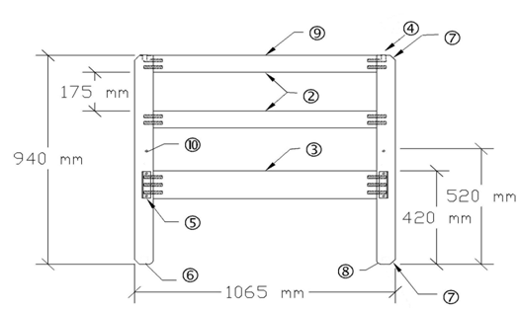
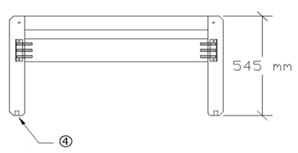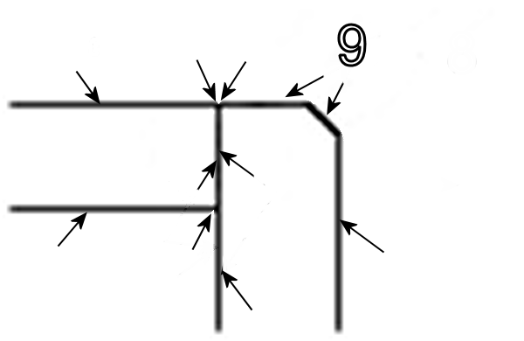
- 76 mm x 44 mm posts. All dowels are 76 mm x 13 mm nominal.
- 76 mm x 44 mm top and middle cross rails, double doweled with face of rails flush with face of posts
- 125 mm x 32 mm lower cross rail, triple doweled, with face of rail flush with outside face of post. Minimum 3 mm radius on all edges, ends and corners.
- 25 mm D X 19 mm diameter hole to receive snug fitting 50 mm long dowels for bunking beds. Wood caps with 25 mm long stem and 25 mm diameter head to cover holes are required when used as a single bed.
- Wedgelocks angle bracket (see 3.2.1.3)
- Glides (See 3.1.6.1)
- Bevel with 30 mm wide face.
- 13 mm radius.
- Minimum 6 mm radius on all edges, ends and corners of posts and top and middle cross rails as shown in detail view.
- Holes for re-positioning of wedgelocks (see: 3.2.1.3)
Contemporary Oak
Vertical End Supports (Headboard, Footboard) for
Type I, Style A Bed, Bunkable
Figure 1
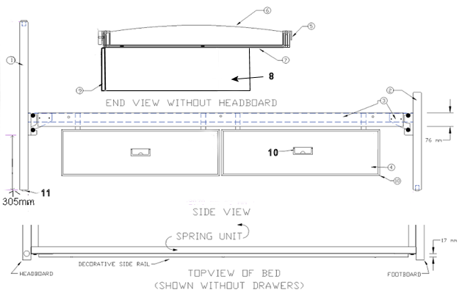
- Headboard (VES, 3.2.1.1)
- Footboard (VES, 3.2.1.1)
- Bed spring deck with wedgelocks and decorative side rails.
- Drawers (under bed mounted,3.2.2)
- Bed spring deck side rails (3.2.1.2)
- Sinuous wire springs (3.2.1.2).
- Drawer case-to-bed mounting panel (3.2.2)
- Drawer unit outer case (3.2.2)
- Drawer front (3.2.2).
- Drawer pulls (3.1.6.3).
- Glides (3.1.6.1) shipped detached.
Contemporary Oak
Type I, Style A Bed, Bunkable and
Type II, Style A Drawer Unit, Wood, Under Bed Mounted
Figure 2

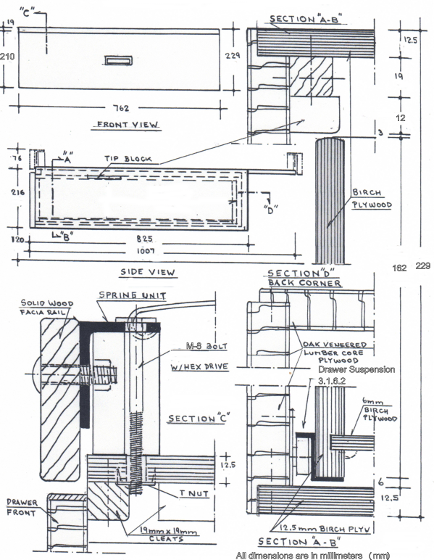
Contemporary Oak
Type II, Style A Drawer Unit, Wood, Under Bed Mounted
Figure 3
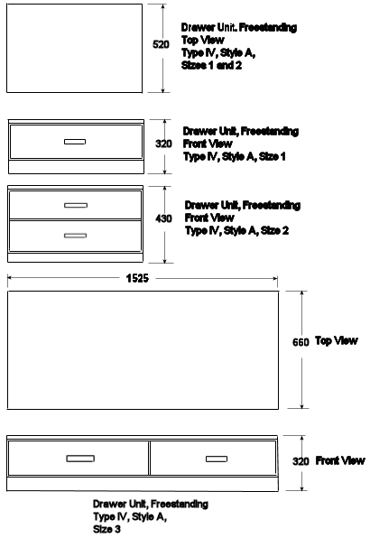
Not to scale
All dimensions are in millimeters (mm)

Contemporary Oak
Type IV, Style A, Drawer Units Freestanding
Figure 4

Twin 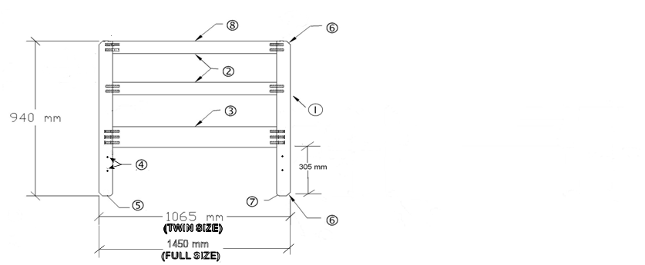
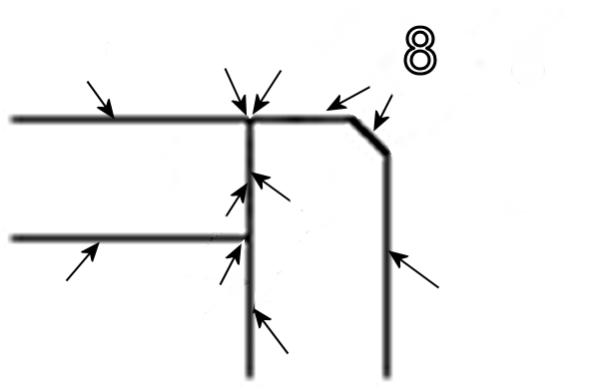
- 76 mm x 44 mm posts. All dowels are 76 mm x 13 mm nominal.
- 76 mm x 44 mm top and middle cross rails, double doweled with face of rails flush with face of posts.
- 125 mm x 32 mm lower cross rail, triple doweled, with face of rail flush with outside face of post. Minimum 3 mm radius on all edges, ends and corners.
- Bore 8 mm through holes (two per post) located for attaching headboard to metal bed frame.
- Glides (See 3.1.6.1).
- Bevel with 30 mm wide face.
- 13 mm radius.
- Minimum 6 mm radius on all edges, ends and corners of posts and top and middle cross rails as shown in detail view.
Contemporary Oak
Type V, Style A, Sizes 1 and 2
Ladder Style Headboard, Twin and Full Sizes
Figure 5

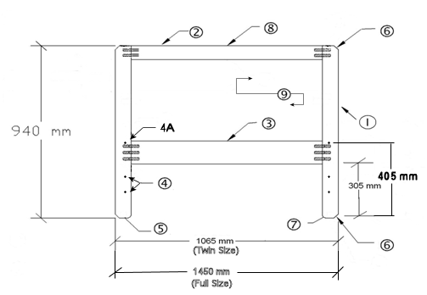
- 76 mm x 44 mm posts. All dowels are 76 mm x 13 mm nominal.
- 76 mm x 44 mm top cross rail, double doweled with face of rail flush with face of posts.
- 125 mm x 32 mm lower cross rail, triple doweled, with face of rail flush with outside face of post. Minimum 3 mm radius on all edges, ends and corners.
- Bore 8 mm through holes (two per post) located for attaching headboard to metal bed frame. These holes shall not be bored in twin headboard shipped with Type VI Platform (Captain’s) Bed.
4A. Bore 10 mm through holes (one per post) in twin size headboard when headboard will be attached to a Type VI Platform (Captain’s) Bed.
- Glides (See 3.1.6.1).
- Bevel with 30mm wide face.
- 13mm radius.
- Minimum 6 mm radius on all edges, ends and corners of posts and top cross rail as shown in detail view.
- 19 mm thick exposed (2 sides) wood panel, grooved four sides into the headboard frame.
Contemporary Oak
Type V, Style B, Sizes 1 and 2
Solid (Panel) Style Headboard, Twin and Full Sizes
(Twin Size headboard used on Type VI, Platform (Captain’s) Bed)
Figure 6
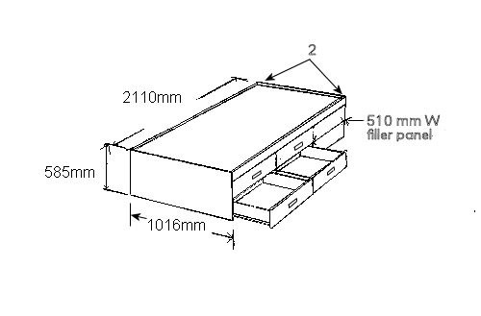

- Type V, Style B, Size 1, Twin, Solid Style Headboard (Figure 6) is used on Type VI, Platform Bed.
- T-nuts required in “head” end panel on platform bed, to receive black, flush head, M-9 (3/8-18) Allen drive bolts for mounting the headboard. One Allen “key” shall be shipped with each bed.

Contemporary Oak
Type VI, Style A
Platform (Captains) Bed, Four Drawer
(Shown without headboard)
Figure 7

