FEDERAL REAL PROPERTY COUNCIL

published by
GSA Office of Governmentwide Policy

FY 2005
Federal Real Property Report

EXECUTIVE SUMMARY REPORT:
An Overview of the U.S. Federal Government’s Real Property Assets

June 2006

www.realpropertyprofile.gov

INTRODUCTION & BACKGROUND

On behalf of the Federal Real Property Council (FRPC), GSA’s Office of Governmentwide Policy (OGP) is pleased to present the results of the FY 2005 governmentwide real property data collection.
Executive Order 13327 created the Federal Real Property Council, established the role of the Senior Real Property Officer, and mandated the creation of a centralized real property database. At the same time, “real property” was added to the President’s Management Agenda.
With the issuance of Executive Order 13327 in February 2004, OGP was formally recognized as the administrator of the centralized real property database, known as the Federal Real Property Profile (FRPP). In 2005, the FRPC defined 23 real property data elements for the FRPP database. All executive branch agencies were required to submit data to the FRPP, at the constructed asset level, for each of the data categories by December 15, 2005.

This executive summary marks the first reporting year for the newly defined, governmentwide data elements, as required by Executive Order 13327. In subsequent years, historical trend analysis of the FRPP data will be possible.

The goals of Executive Order 13327 are to:
- Promote efficient and economical use of real property resources.
- Increase agency accountability and management attention to real property reform.
- Establish clear real property goals and objectives.
The goals of the centralized database are to:
- Improve decision making with accurate and reliable data.
- Provide the ability to benchmark Federal real property assets.
- Consolidate governmentwide real property data collection into one system.

We would like to recognize the tremendous effort undertaken by the Federal agencies to capture and report on the 23 data elements defined by the FRPC. Within one year of issuing the FRPC guidance, agencies have overcome many obstacles in order to successfully report the required data.

We also thank the FRPC Committees, especially the Inventory Committee, for the numerous hours they devoted to this initiative. The Committees collaborated to develop detailed specifications for a Federal database capable of handling data for one of the world’s most complex and diverse real estate portfolios.

We particularly thank the Chair of the Inventory Committee, Phil Grone, from the Department of Defense, and the Co-Chairs of the Inventory Committee’s Technical Working Group, Stan Kaczmarczyk (GSA) and Lora Muchmore (DOD).

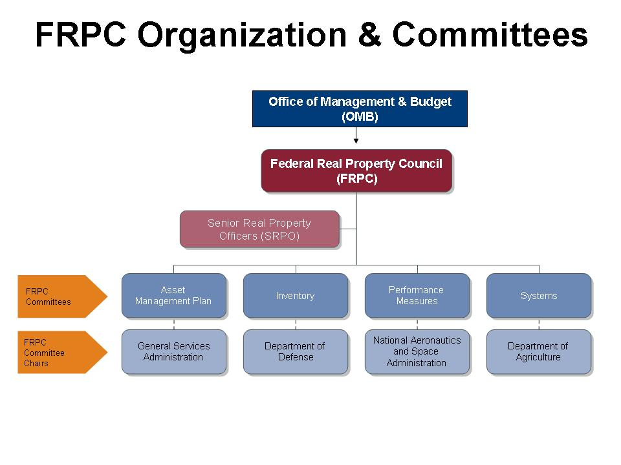
Performance Measures Committee became a working group of the Inventory Committee in March 2006.

FEDERAL REAL PROPERTY: KEY STATISTICS

Total Federal Assets | 1,210,411 assets
- Total Building Assets | 501,128 assets
- Total Structures | 475,054 assets
- Total Land* | 234,229 land records*
Total Area of Building Assets | 3.73 billion square feet
Building Asset Location Profile:  U.S., U.S. Territories, Foreign | 86% U.S.  1% U.S. Territories  13% Foreign
Total Replacement Value of Assets  (Buildings and Structures) | $1.26 trillion
- Replacement Value of Building Assets | $684.9 billion
- Replacement Value of Structures | $571.3 billion
Legal Interest of Building Assets (by SF) | 79% owned  12% leased  9% otherwise managed
- Largest Owner of Building Assets | Army: 660 million square feet owned
- Largest Lessee of Building Assets | GSA: 169 million square feet leased
Legal Interest of Structures (by number) | 85% owned  6% leased  9% otherwise managed
- Largest Owner of Structures | Interior: 101,890 structures with $146 billion in replacement value
Total Federal Land* | 54,914,928 acres*

* Executive Order 13327 does not mandate the reporting of data for public domain lands and certain asset types. Therefore, the FY 2005 land data does not fully represent the Federal Government’s total land acreage and FY 2004 and FY 2005 land data are not comparable. “Total Federal Assets” and “Federal Land” includes overseas land owned by a foreign government and provided for U.S. government purposes, or land owned by a foreign entity and leased to the U.S. government.

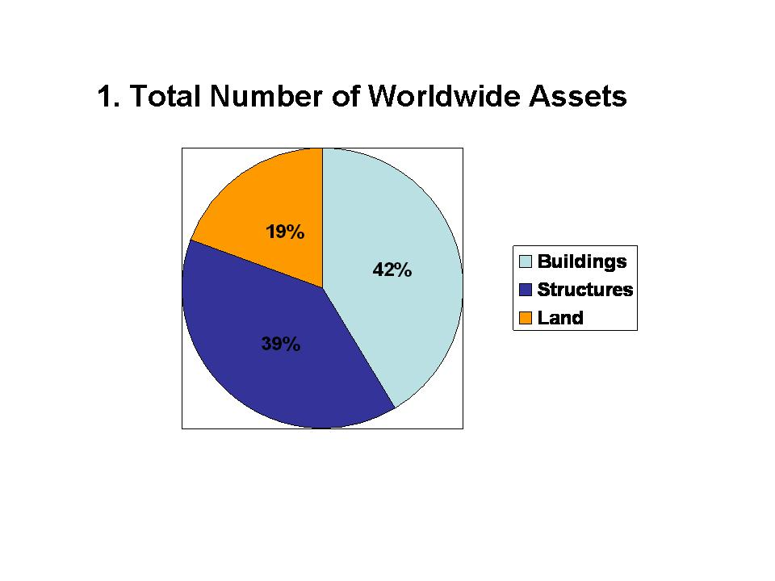
Number of Building Assets | Number of Structures | Number of Land Records* | TOTAL NUMBER OF ASSETS
501,128 | 475,054 | 234,229* | 1,210,411

*Notes
- Executive Order 13327 does not mandate the reporting of data for public domain lands and certain other types of assets. Therefore, the FY 2005 land data does not fully represent the Federal Government’s total land acreage and FY 2004 and FY 2005 land data are not comparable.
- Total Federal asset count includes all U.S., U.S. territories, and foreign assets.

Improved real property data and agency performance will:
- Reduce operating costs
- Improve asset utilization
- Recover asset value
- Improve facility conditions
- Create more productive workplaces
- Enhance safety and security

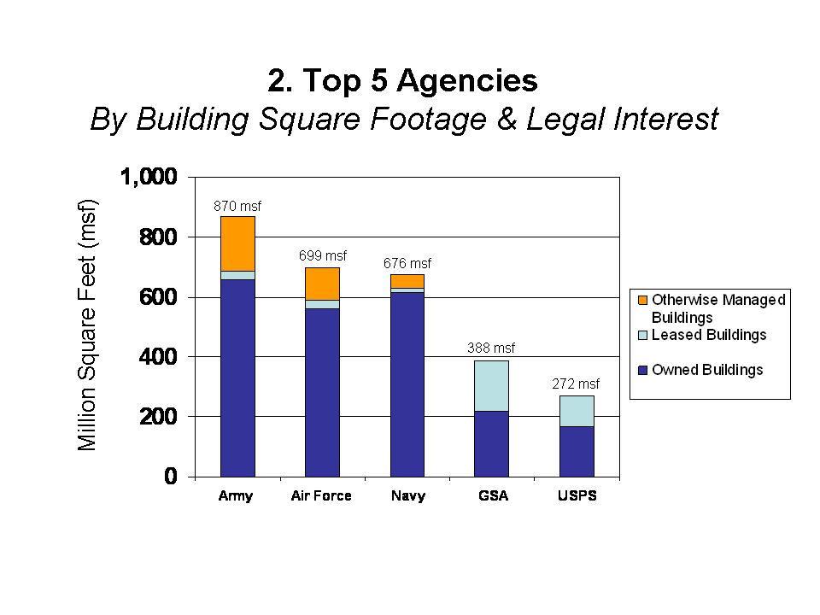
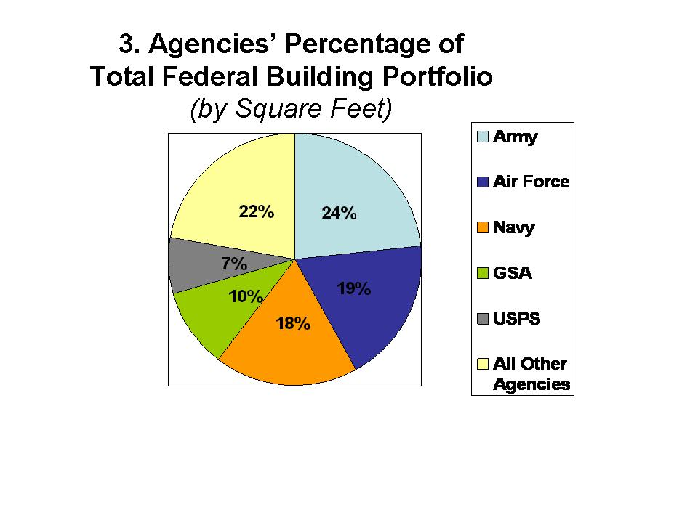
Notes
- Building square footage includes all locations (domestic, foreign, and U.S. territories) and all legal interest types (owned, leased, and otherwise managed).

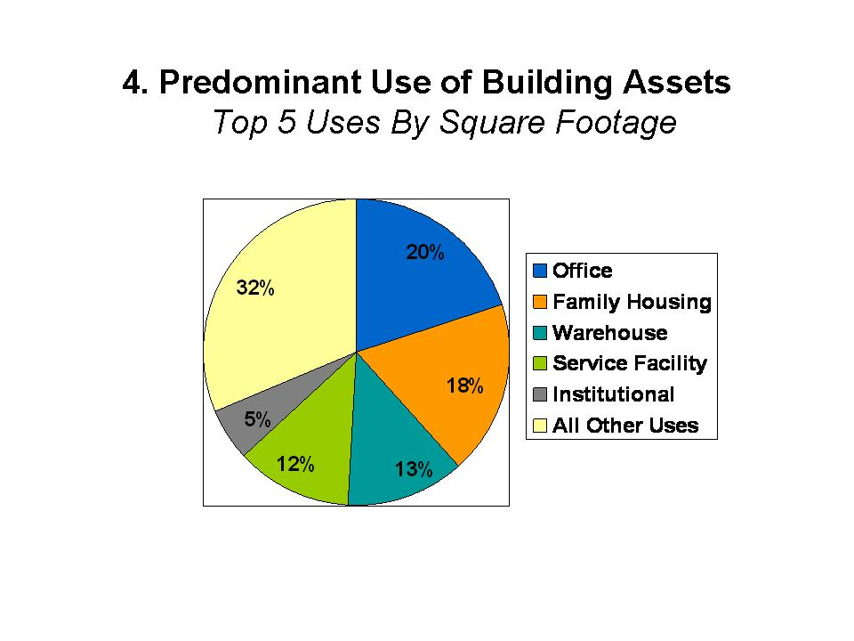
Predominant Use | Square Feet (SF)
Office | 745,201,480
Family Housing | 687,330,307
Warehouse | 466,447,830
Service Facility | 455,222,266
Institutional | 202,282,472
All Other Uses | 1,173,300,847
TOTAL SQUARE FEET | 3,729,785,202 SF

*Notes
- Top 5 predominant uses were determined by the square footage size of building assets.

Definitions
- Office: Buildings primarily used for office space or military headquarters.
- Family Housing: Buildings primarily used as dwellings for families/dependents. Includes apartment houses, single houses, row houses, public housing, military personnel housing, Federal employee housing, and housing for institutional personnel.
- Warehouse: Buildings used for storage, such as ammunition storage, covered sheds, and buildings primarily used for storage of vehicles or materials. Also included are underground or earth covered ammunition storage bunkers and magazines. This category excludes water reservoirs and POL storage tanks which are storage structures.
- Service Facility: Buildings used for service activities, such as maintenance and repair shops, dry cleaning plants, post exchange stores, airport hangars, and buildings primarily used for vehicle maintenance and repair.
- Institutional: Buildings used for institutional purposes other than schools, hospitals, and prisons, such as libraries, chapels, museums, and out-patient clinics. This category also includes food preparation and dining facilities, buildings housing entertainment and recreational activities, and visitor’s centers.
- All Other: Includes all other predominant use categories, which are: hospital, post office, prison, school, dormitories/barracks, industrial, communications systems, navigation and traffic aids, laboratories, and all other buildings that cannot be classified elsewhere.

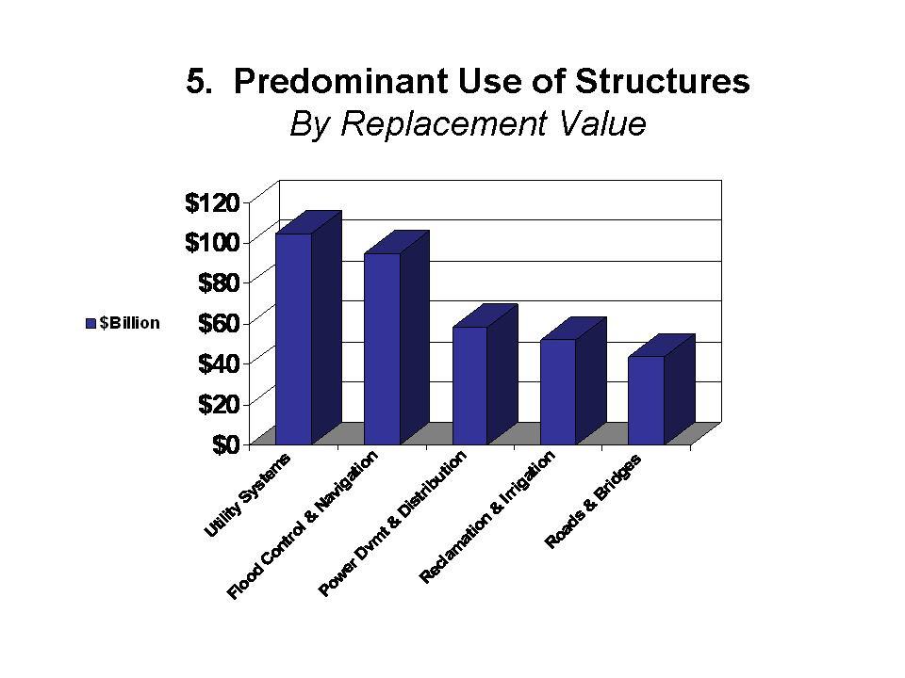

Predominant Use | Replacement Value
Utility Systems | $104,737,372,926
Flood Control and Navigation | $94,975,607,778
Power Development and Distribution | $58,314,021,116
Reclamation and Irrigation | $52,334,201,592
Roads and Bridges | $42,964,094,359
All Other Structure Uses | $194,972,197,162
TOTAL REPLACEMENT VALUE | $571,284,928,313

Definitions
- Utility Systems: Heating, sewage, water, and electrical systems when they serve several buildings or other structures of an installation. Includes heating plants and related steam and gas lines; sewage disposal plants; storm and sanitary sewer lines; water treatment plants, wells, pump houses, reservoirs, and pipelines; electrical substations; standby or auxiliary power plants; lighting structures and conduits.
- Flood Control and Navigation: River improvements, revetments, dikes, dams, and docks.
- Power Development and Distribution: Hydroelectric and other power development projects that produce power for resale (generally consisting of dams and powerhouses). Includes transmission lines.
- Reclamation and Irrigation: Canals, laterals, pumping stations, storage, and diversion dams.
- Roads and Bridges: Federally-owned highways, roads, related culverts, and connecting bridges. Includes surfaced and unsurfaced roads within national parks and forests, military installations, and other federal installations.
- All Other Predominant Uses include airfield pavements, harbors and ports, storage (other than buildings), industrial (other than buildings), service (other than buildings), space exploration structures, parking structure, research and development (other than laboratories), communications systems, navigation and traffic aids (other than buildings), recreational (other than buildings), railroads, monuments and memorials, miscellaneous military facilities, weapons ranges, and other structures that cannot be classified under the above categories.

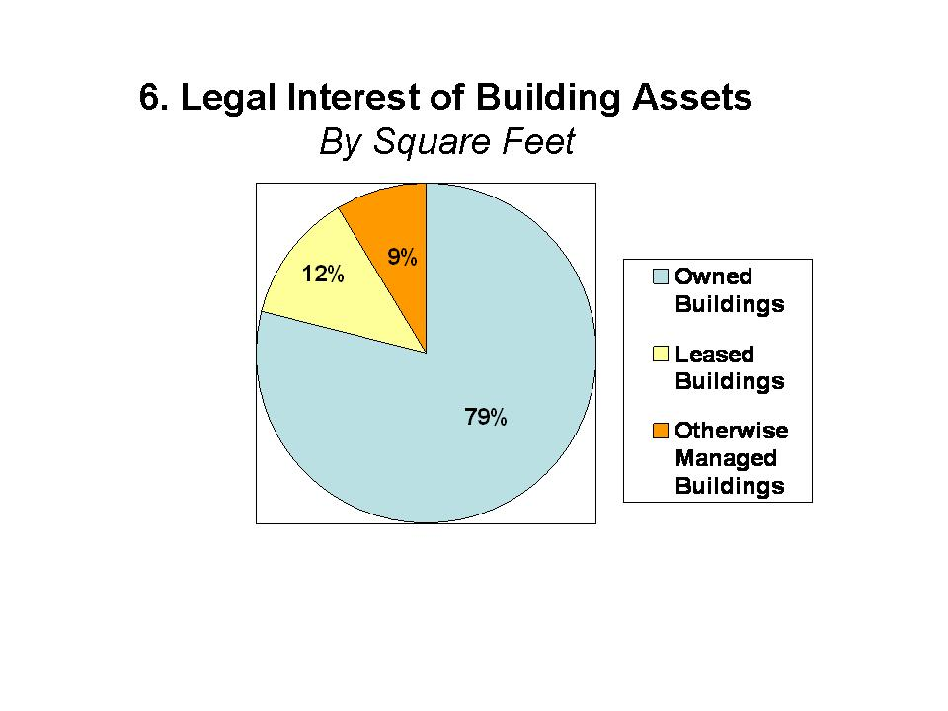
LOCATION | Owned Building Assets | Leased Building Assets | Otherwise Managed Building Assets | TOTALS
United States (U.S.) | 2,817,471,004 | 379,842,263 | 779,264 | 3,198,092,531
U.S. Territories | 28,515,754 | 1,967,310 | 8,570 | 30,491,634
Foreign (non-U.S.) | 62,405,631 | 77,612,829 | 321,459,087 | 461,477,547
Locations Not Reported | 7,291,707 | 703,144 | 31,728,638 | 39,723,489
TOTAL SQUARE FEET | 2,915,684,096 | 460,125,546 | 322,246,921 | 3,729,785,201

Definitions
- Owned: The Federal government has fee-simple interest for the real property.
- Leased: The rights to use the real property have been assigned to the Federal government by a private entity or a non-Federal government entity for a defined period of time in return for rental payments.
- Otherwise Managed properties are State Government-Owned or Foreign Government-Owned, in which a U.S. state or foreign government holds title to the real property but rights for use have been granted to a Federal government entity in other than a leasehold arrangement.

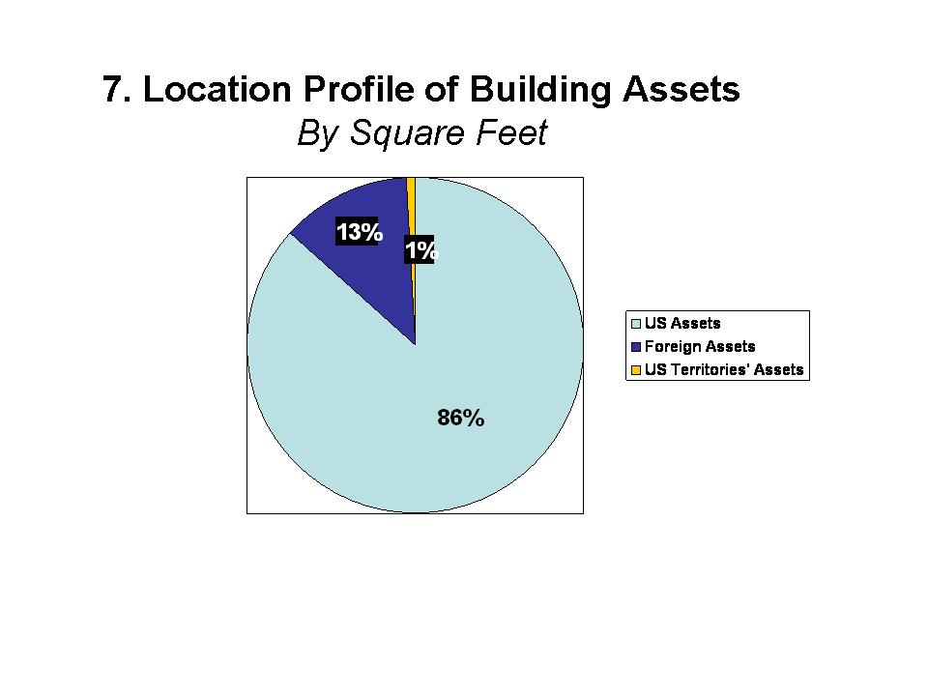
Notes
- U.S. Assets are located within the 50 states and District of Columbia. Foreign assets are those assets located outside the U.S. and its territories.
- Assets in U.S. Territories include assets located in American Samoa, Baker Island, Federated States of Micronesia, Guam, Howland Island, Jarvis Island, Johnston Atoll, Kingman Reef, Marshall Islands, Midway Islands, Navassa Island, Northern Mariana Island, Palmyra Atoll, Republic of Paulau, Puerto Rico, the U.S. Virgin Islands, U.S. Minor Outlying Islands, and Wake Island.
- Foreign Assets are located outside the U.S. and its territories.

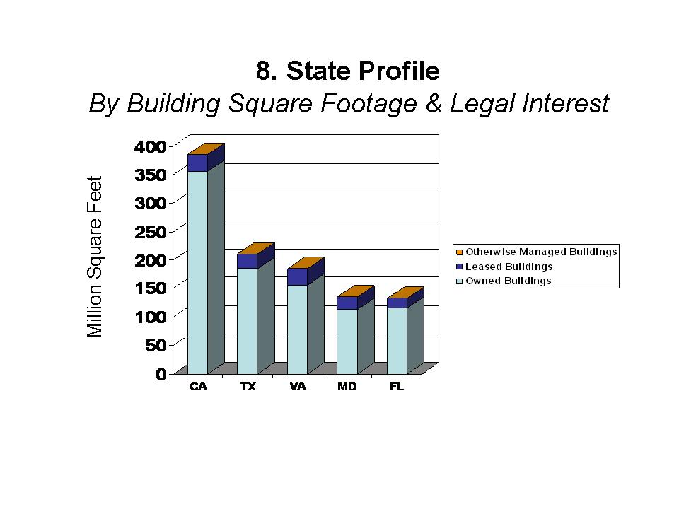

Table 1.
STATE | Owned SF | Leased SF | Otherwise Managed SF | Total SF
Alabama | 53,520,462 | 5,897,043 | 8,662 | 59,426,167
Alaska | 50,801,698 | 5,131,342 | 13,144 | 55,946,184
Arizona | 56,426,079 | 4,841,312 | 29,786 | 61,297,177
Arkansas | 21,502,889 | 2,930,705 | 0 | 24,433,594
California | 355,747,932 | 29,520,438 | 72,918 | 385,341,288
Colorado | 54,495,637 | 8,390,122 | 27,280 | 62,913,039
Connecticut | 17,043,912 | 1,841,749 | 0 | 18,885,661
Delaware | 7,805,392 | 498,157 | 0 | 8,303,549
District of Columbia | 68,413,986 | 22,668,988 | 0 | 91,082,974
Florida | 115,607,493 | 16,748,418 | 109,003 | 132,464,914
Georgia | 112,656,529 | 13,208,718 | 0 | 125,865,247
Hawaii | 59,967,355 | 1,335,903 | 0 | 59,303,258
Idaho | 17,755,511 | 2,972,919 | 6,826 | 20,735,256
Illinois | 81,040,149 | 8,657,352 | 20,000 | 89,717,501
Indiana | 31,724,753 | 4,547,101 | 0 | 36,271,854
Iowa | 12,453,286 | 3,810,197 | 0 | 16,263,483
Kansas | 41,117,701 | 4,334,027 | 0 | 45,451,728
Kentucky | 51,547,758 | 4,283,235 | 0 | 55,830,993
Louisiana | 41,361,467 | 6,392,189 | 42,571 | 47,796,227
Maine | 11,864,461 | 1,571,600 | 0 | 13,436,061
Maryland | 112,762,295 | 22,500,682 | 2,450 | 135,265,427
Massachusetts | 34,893,027 | 5,982,357 | 119,830 | 40,995,214
Michigan | 28,710,587 | 6,931,845 | 16,990 | 35,659,422
Minnesota | 19,351,202 | 3,445,479 | 0 | 22,796,681
Mississippi | 34,990,961 | 3,489,383 | 0 | 38,480,344
Missouri | 48,109,225 | 9,070,782 | 1,200 | 57,181,207
Montana | 14,750,702 | 2,547,331 | 0 | 17,298,033
Nebraska | 13,816,517 | 2,513,987 | 0 | 16,330,504
Nevada | 31,710,007 | 2,686,735 | 3,091 | 34,399,833
New Hampshire | 3,324,553 | 1,261,136 | 834 | 4,586,523
New Jersey | 46,376,442 | 9,271,935 | 0 | 55,648,377
New Mexico | 58,420,280 | 5,202,239 | 2,176 | 63,624,695
New York | 98,312,394 | 19,163,838 | 16,482 | 117,492,714
North Carolina | 86,879,855 | 7,433,528 | 0 | 94,313,383
North Dakota | 20,069,498 | 1,451,558 | 19,836 | 21,540,892
Ohio | 69,883,325 | 8,640,064 | 409 | 78,523,798
Oklahoma | 56,912,654 | 8,526,293 | 0 | 65,438,947
Oregon | 22,117,017 | 4,375,486 | 320 | 26,492,823
Pennsylvania | 76,089,435 | 13,055,268 | 0 | 89,144,703
Rhode Island | 13,547,767 | 684,116 | 11,634 | 14,243,517
South Carolina | 62,958,162 | 3,290,609 | 0 | 66,248,771
South Dakota | 15,888,229 | 3,221,841 | 0 | 19,110,070
Tennessee | 67,833,341 | 6,096,336 | 1,812 | 73,931,489
Texas | 184,673,541 | 26,290,654 | 39,030 | 211,003,225
Utah | 31,745,434 | 4,259,063 | 0 | 36,004,497
Vermont | 2,739,452 | 1,367,870 | 0 | 4,107,322
Virginia | 155,933,110 | 28,997,337 | 0 | 184,930,447
Washington | 85,889,378 | 7,805,394 | 0 | 93,694,772
West Virginia | 18,261,516 | 3,481,825 | 0 | 21,743,341
Wisconsin | 21,861,580 | 4,958,101 | 0 | 26,819,681
Wyoming | 13,791,655 | 909,900 | 0 | 14,701,555
Locations Not Reported | 4,013,418 | 1,347,776 | 212,976 | 5,574,170
TOTALS | 2,815,457,591 SF | 378,494,487 SF | 566,284 SF | 3,198,092,532 SF

The Top 5 States (CA, TX, VA, MD, FL) comprise
33% of the total Federal building portfolio,
measured by square footage.

AGENCY PROFILE
Building Assets By Legal Interest & Square Footage

Building Assets | Structures | TOTAL REPLACEMENT VALUE
$684.9 billion | $571.3 billion | $1.26 trillion

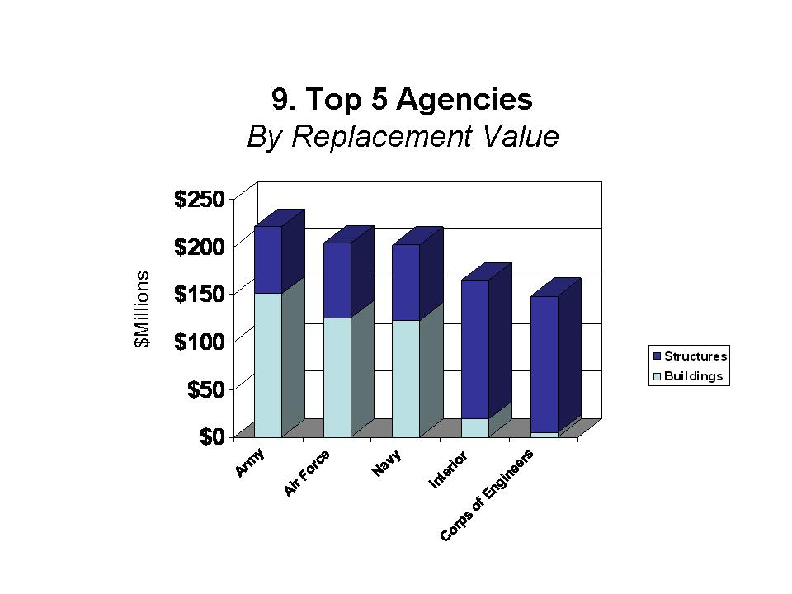
Agency | Building Assets - Replacement Value | Structures - Replacement Value | Total Replacement Value
Army | $150.6 billion | $70.4 billion | $221.0 billion
Air Force | $125.3 billion | $78.3 billion | $203.6 billion
Navy | $122.6 billion | $79.4 billion | $202.0 billion
Dept. of Interior | $18.5 billion | $146.4 billion | $164.8 billion
Corps of Engineers | $4.7 billion | $143.4 billion | $148.1 billion

Definitions
- Replacement Value: The cost to replace the existing constructed asset at today’s standards and today’s dollars.
- Structures are classified as airfield pavements, harbors and ports, power development and distribution, reclamation and irrigation, flood control and navigation, storage (other than buildings), industrial (other than buildings), service (other than buildings), space exploration structures, parking structure, research and development (other than laboratories), utility systems, communications systems, navigation and traffic aids (other than buildings), recreational (other than buildings), roads and bridges, railroads, monuments and memorials, miscellaneous military facilities, weapons ranges, and other structures that cannot be classified under the above categories.

AGENCY PROFILE

Building Assets By Legal Interest & Square Footage

Table 2.
Agency Name | Owned Square Feet | Leased Square Feet | Otherwise Managed Square Feet | TOTAL SQUARE  FEET
Agriculture | 39,577,343 | 14,925,532 | 0 | 54,502,875
Air Force | 559,299,887 | 28,859,314 | 111,113,849 | 699,273,050
American Battle Monuments Commission | 0 | 2,000 | 442,460 | 444,460
Army | 660,398,263 | 25,694,426 | 183,565,355 | 869,658,044
Commerce | 6,555,724 | 912,733 | 0 | 7,468,457
Corps of Engineers | 13,385,284 | 20,345,169 | 0 | 33,730,453
Defense/WHS | 8,639,542 | 758,785 | 0 | 9,398,327
Energy | 125,041,236 | 6,439,987 | 0 | 131,481,223
Environmental Protection Agency | 3,739,583 | 243,732 | 0 | 3,983,315
General Services Administration | 218,983,699 | 168,857,475 | 0 | 387,841,174
Health and Human Services | 31,449,459 | 3,952,982 | 0 | 35,402,441
Homeland Security | 40,040,320 | 1,292,741 | 0 | 41,333,061
Independent Government Offices | 711,519 | 28,754 | 0 | 740,273
Interior | 89,923,692 | 3,730,792 | 421,376 | 94,075,860
Justice | 65,453,695 | 2,879,846 | 0 | 68,333,541
Labor | 20,577,776 | 3,906,290 | 0 | 24,484,066
National Aeronautics and Space Administration | 44,352,539 | 656,718 | 0 | 45,009,257
National Archives and Records Administration | 3,928,964 | 543,194 | 0 | 4,472,158
National Science Foundation | 1,738,142 | 198,183 | 8,691 | 1,945,016
Navy | 615,367,331 | 14,080,086 | 46,119,134 | 675,566,551
Peace Corps | 0 | 2,574,659 | 0 | 2,574,659
State | 22,207,031 | 37,006,356 | 12,205,842 | 71,419,229
State (USAID) | 567,374 | 4,261,254 | 98,852 | 4,927,480
Tennessee Valley Authority | 4,323,627 | 0 | 0 | 4,323,627
Transportation | 19,045,921 | 7,512,592 | 0 | 26,558,512
Treasury | 4,268,741 | 1,430,460 | 0 | 5,699,201
United States Postal Service | 170,211,194 | 101,783,054 | 0 | 271,994,249
Veterans Affairs | 145,896,210 | 7,248,432 | 0 | 153,144,642
TOTALS | 2,915,684,096 | 460,125,546 | 353,975,559 | 3,729,785,201

All square feet data is represented in gross square feet.
U.S. assets are located within the 50 states and District of Columbia. Assets in U.S. Territories include all those located in American Samoa, Baker Island, Federated States of Micronesia, Guam, Howland Island, Jarvis Island, Johnston Atoll, Kingman Reef, Marshall Islands, Midway Islands, Navassa Island, Northern Mariana Islands, Palmyra Atoll, Republic of Paulau, Puerto Rico, the U.S. Virgin Islands, U.S. Minor Outlying Islands, and Wake Island. Foreign assets are located outside the U.S. and its territories.
Replacement value is defined as the cost to replace the existing asset at today’s standards and in today’s dollars.
Otherwise managed properties are state government-owned or foreign government-owned properties where a U.S. state or foreign government holds title to the real property but rights for use have been granted to a Federal government entity in other than a leasehold arrangement.

