GENERAL SERVICES ADMINISTRATION Washington, DC 20405 February 20, 2008
FEDERAL MANAGEMENT REGULATION
Amendment 2008-03
TO: Heads of Federal agencies
SUBJECT: FMR Case 2008-102-1; Change in Consumer Price IndexMinimal Value
- Purpose. This document includes pages that reflect amendmentsto Part 102-42 of the Federal Management Regulation (FMR).
- Background. Public Law 95-105 requires that at 3-yearintervals following January 1, 1981, minimal value for foreigngifts be redefined by the Administrator of General Services,after consultation with the Secretary of State, to reflectchanges in the Consumer Price Index for the immediately preceding3-year period. The required consultation has been completed andthe minimal value has been increased to mean $335 or less as of January 1, 2008.
  - 3. Effective date. This rule was published in the Federal Register at 73 FR 7475 and became effective on February 8, 2008.
  - Applicability date. January 1, 2008.
- Explanation of changes. Section 102-42-10 is amended in the definition of Minimal value, to reflect that the minimal valuehas been increased to mean $335 or less.

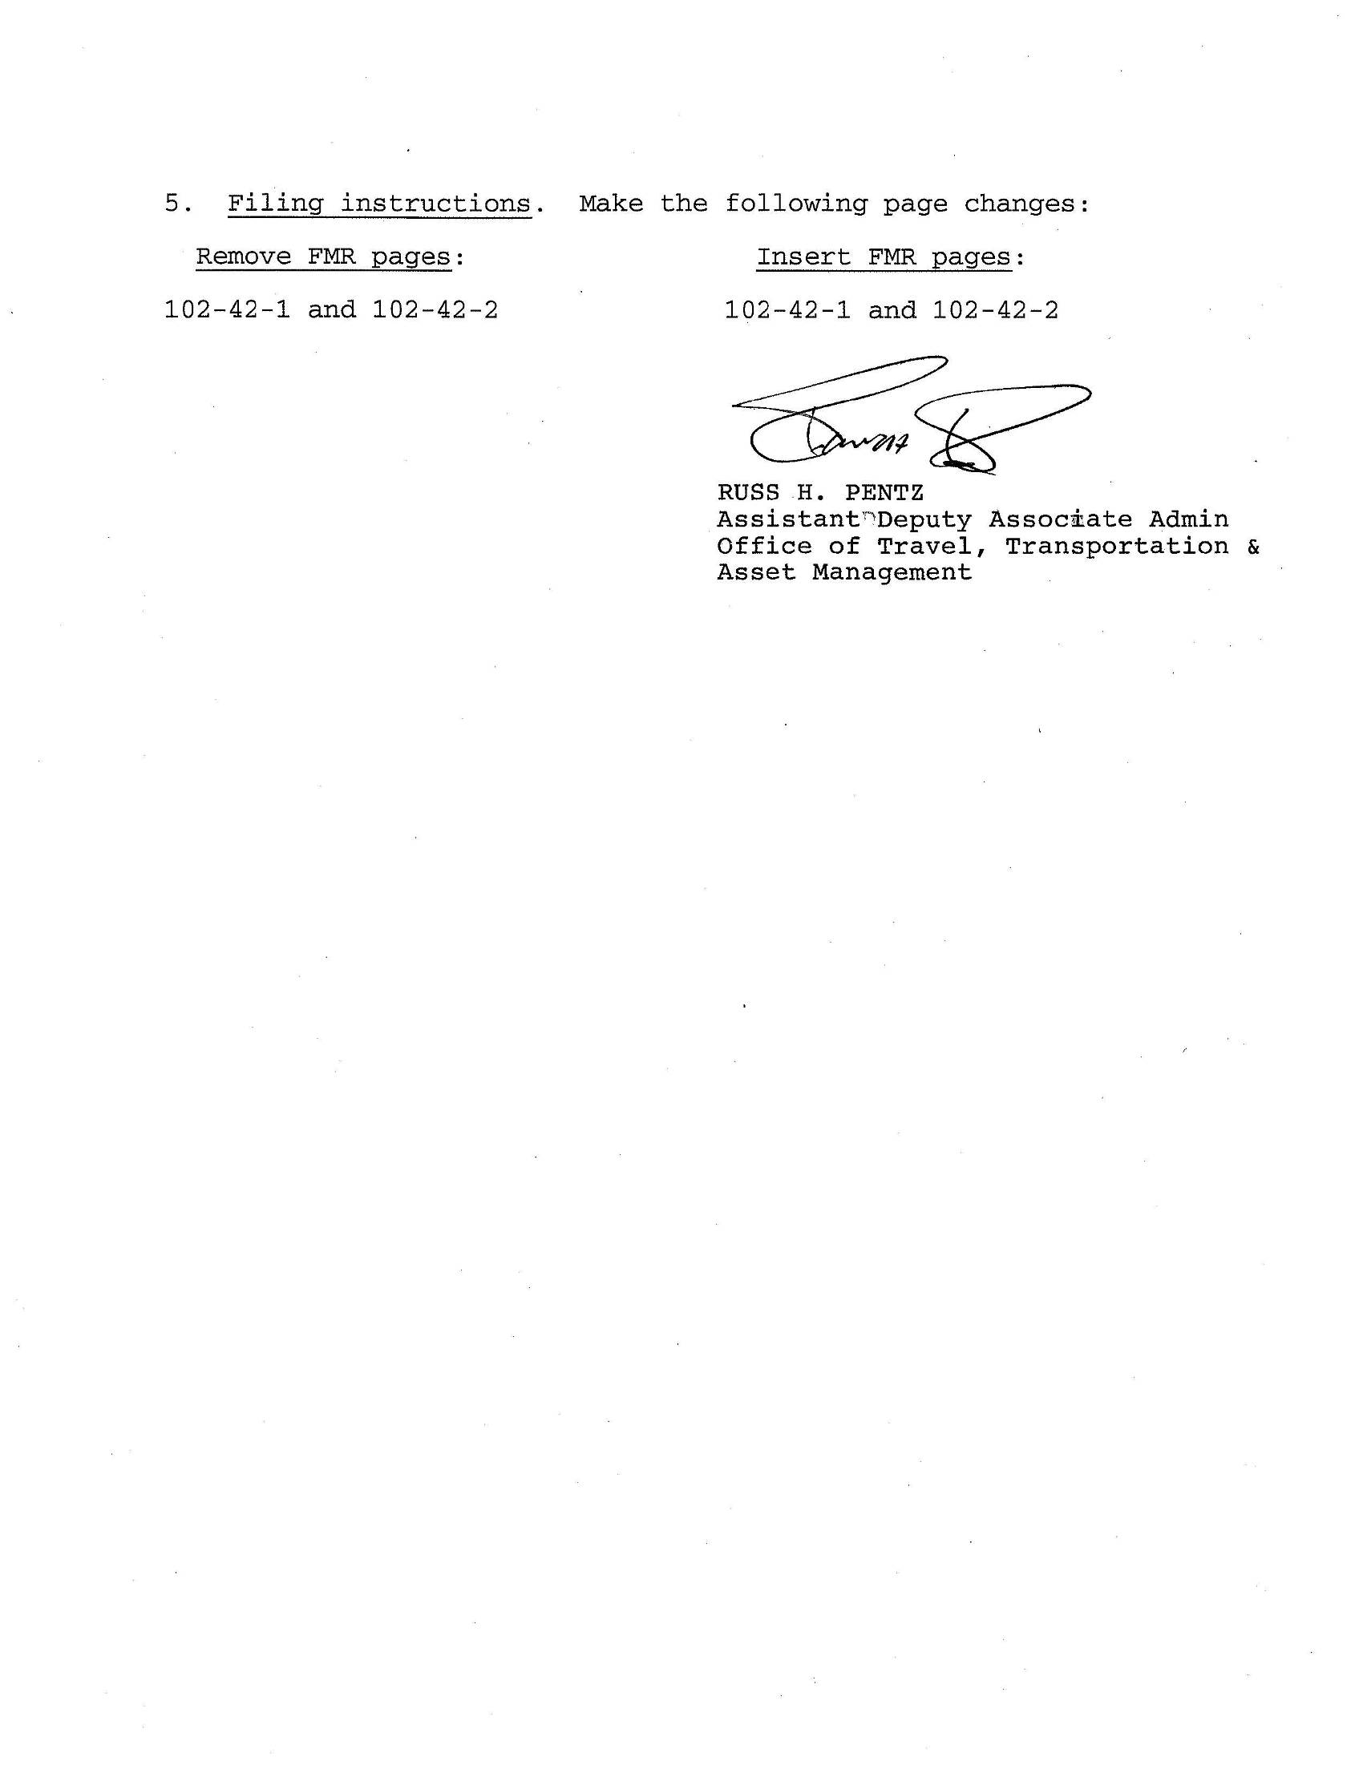
AMENDMENT 2008–03 FEBRUARY 8, 2008
PART 102-42—UTILIZATION, DONATION, AND DISPOSAL OF FOREIGN GIFTS AND DECORATIONS §102-42.15
PART 102-42—UTILIZATION, DONATION, AND DISPOSAL OF FOREIGN GIFTSAND DECORATIONS
Subpart A—General Provisions
§102-42.5—What does this part cover?
This part covers the acceptance and disposition of gifts of more than minimal value and decorations from foreign governments under 5 U.S.C. 7342. If you receive gifts other than from a foreign government, you should refer to §102-36.405 of this subchapter B.
Definitions
§102-42.10—What definitions apply to this part?
The following definitions apply to this part:
“Decoration” means an order, device, medal, badge, insignia, emblem, or award offered by or received from a foreign government.
“Employee” means:
- (1) An employee as defined by 5 U.S.C. 2105 and an officer or employee of the United States Postal Service or of the Postal Rate Commission;
- (2) An expert or consultant who is under contract under 5 U.S.C. 3109 with the United States or any agency, department, or establishment thereof, including, in the case of an organization performing services under that section, any individual involved in the performance of such services;
- (3) An individual employed by or occupying an office or position in the government of a territory or possession of the United States or the government of the District of Columbia;
  - (4) A member of a uniformed service as specified in 10 U.S.C. 101;
  - (5) The President and the Vice President;
- (6) A Member of Congress as defined by 5 U.S.C. 2106 (except the Vice President) and any Delegate to the Congress; and
  - (7) The spouse of an individual described in paragraphs (1) through (6) of this definition of “employee” (unless this individual and his or her spouse are separated) or a dependent (within the meaning of section 152 of the Internal Revenue Code of 1986 (26 U.S.C. 152)) of this individual, other than a spouse or dependent who is an employee under paragraphs (1) through (6) of this definition of “employee.”
  - “Employing agency” means:
- (1) The department, agency, office, or other entity in which an employee is employed, for other legislative branch employees and for all executive branch employees;
- (2) The Committee on Standards of Official Conduct of the House of Representatives, for Members and employees of the House of Representatives, except that those responsibili

ties specified in 5 U.S.C. 7342(c)(2)(A), (e)(1), and (g)(2)(B) must be carried out by the Clerk of the House;
(3) The Select Committee on Ethics of the Senate, for Senators and employees of the Senate, except that those responsibilities (other than responsibilities involving approval of the employing agency) specified in 5 U.S.C. 7342(c)(2), (d), and (g)(2)(B) must be carried out by the Secretary of the Senate; and
(4) The Administrative Offices of the United States
Courts, for judges and judicial branch employees. “Foreign government” means:
- (1) Any unit of foreign government, including any national, State, local, and municipal government and their foreign equivalents;
- (2) Any international or multinational organization whose membershipis composed of anyunit of a foreigngovernment; and
- (3) Any agent or representative of any such foreign government unit or organization while acting as such.

“Gift” means a monetary or non-monetary present (other than a decoration) offered by or received from a foreign government. A monetary gift includes anything that may commonly be used in a financial transaction, such as cash or currency, checks, money orders, bonds, shares of stock, and other securities and negotiable financial instruments.
“Minimal value” means a retail value in the United States at the time of acceptance of $335 or less, except that GSA will adjust the definition of minimal value in regulations prescribed by the Administrator of General Services every three years, in consultation with the Secretary of State, to reflect changes in the consumer price index for the immediately preceding 3-year period.
Care, Handling and Disposition
§102-42.15—Under what circumstances may an employee retain a foreign gift or decoration?
Employees, with the approval of their employing agencies, may accept and retain:
- (a) Gifts of minimal value received as souvenirs or marks of courtesy. When a gift of more than minimal value is accepted, the gift becomes the property of the U.S. Government, not the employee, and must be reported.
- (b) Decorations that have been offered or awarded for outstanding or unusually meritorious performance. If the employing agency disapproves retention of the decoration by the employee, the decoration becomes the property of the

U.S. Government.
102-42-1
AMENDMENT 2006-04 JUNE 19, 2006
§102-42.20 FEDERAL MANAGEMENT REGULATION
§102-42.20—What is the typical disposition process for gifts and decorations that employees are not authorized to retain?
- (a) Non-monetary gifts or decorations. When an employee receives a non-monetary gift above the minimal value or a decoration that he/she is not authorized to retain:
- (1) The employee must report the gift or decoration to his/her employing agency within 60 days after accepting it.
- (2) The employing agency determines if it will keep the gift or decoration for official use.
- (3) If it does not return the gift or decoration to the donor or keep it for official use, the employing agency reports it as excess personal property to GSA for Federal utilization screening under §102-42.95.
- (4) If GSA does not transfer the gift or decoration during Federal utilization screening, the employee may purchase the gift or decoration (see §102-42.140).
- (5) If the employee declines to purchase the gift or decoration, and there is no Federal requirement for either, GSA may offer it for donation through State Agencies for Surplus Property (SASP) under part 102-37 of this subchapter B.
- (6) If no SASP requests the gift or decoration for donation, GSA may offer it for public sale, with the approval of the Secretary of State, or will authorize the destruction of the gift or decoration under part 102-38 of this subchapter B.
- (b) Monetary gifts. When an employee receives a monetary gift above the minimal value:
  - (1) The employee must report the gift to his/her employing agency within 60 days after accepting it.
  - (2) The employing agency must:
- (i) Report a monetary gift with possible historic or numismatic (i.e., collectible) value to GSA; or
- (ii) Deposit a monetary gift that has no historic or numismatic value with the Department of the Treasury.

§102-42.25—Who retains custody of gifts and decorations pending disposal?
- (a) The employing agency retains custody of gifts and decorations that employees have expressed an interest in purchasing.
- (b) GSA will accept physical custody of gifts above the minimal value, which employees decline to purchase, or decorations that are not retained for official use or returned to donors.

Note to §102-42.25(b): GSA will not accept physical custody of foreign gifts of firearms. Firearms reported by the agency as excess must be disposed of in accordance with part 101-42 of this title.
§102-42.30—Who is responsible for the security, care and
handling, and delivery of gifts and decorations to GSA,
and all costs associated with such functions?
The employing agency is responsible for the security, care and handling, and delivery of gifts and decorations to GSA, and all costs associated with such functions.
§102-42.35—Can the employing agency be reimbursed for transfers of gifts and decorations?
No, all transfers of gifts and decorations to Federal agencies or donation through SASPs will be without reimbursement. However, the employing agency may require the receiving agency to pay all or part of the direct costs incurred by the employing agency in packing, preparation for shipment, loading, and transportation.
Appraisals
§102-42.40—When is a commercial appraisal necessary?
- (a) A commercial appraisal is necessary when an employee indicates an interest in purchasing a gift or decoration and must be obtained before the gift or decoration is reported to GSA for screening.
- (b) GSA may also require the employing agency to obtain a commercial appraisal of a gift or decoration that the agency no longer needs before accepting the agency’s report of the item as excess personal property.

§102-42.45—Who obtains a commercial appraisal?
The employing agency obtains a commercial appraisal.
§102-42.50—Is there a special format for a commercial appraisal?
There is no special format for a commercial appraisal, but it must be:
- (a) On official company letterhead;
- (b) Prepared in the United States;
- (c) Dated; and
- (d) Expressed in U.S. dollars.

§102-42.55—What does the employing agency do with the appraisal?
The employing agency must attach the commercial appraisal to a Standard Form (SF) 120, Report of Excess Personal Property.
Special Disposals
§102-42.60—Who is responsible for gifts and decorations received by Senators and Senate employees?
Gifts and decorations received by Senators and Senate employees are deposited with the Secretary of the Senate for disposal by the Commission on Art and Antiquities of the
102-42-2

